**Clustering of sequences of weekly clusters**

The idea was to create, for each student, a learning trajectory – a sequence – out of the clusters the student belonged to in each of the course weeks (2-13).

Since too many different clusters were identified for the 12 course weeks – 19 in total – it was impossible to create sequences with that diversity of possible states. So, the first step was to create a ‘compact clustering scheme’ by (manually) merging two or more (semantically) similar clusters into one. This resulted in a ‘compact clusters scheme’ comprising 11 different clusters. However, that number was still high relative to the size of the dataset, i.e., the number of instances (n=290), especially considering that many observations had missing values for at least one state (i.e., weekly cluster – for the week they were not active on the course LMS).

So, the next step was to make this ‘compact clusters scheme’ even coarser grained. This resulted in a ‘coarse grained cluster scheme’ consisting of 5 different clusters: highly active, active, moderately active, summative assessment only, and disengaged. These clusters represented ‘states’ out of which sequences are formed for each student.

The figure gives a birds’-eye view of the crated sequences (for all the students, n=290).

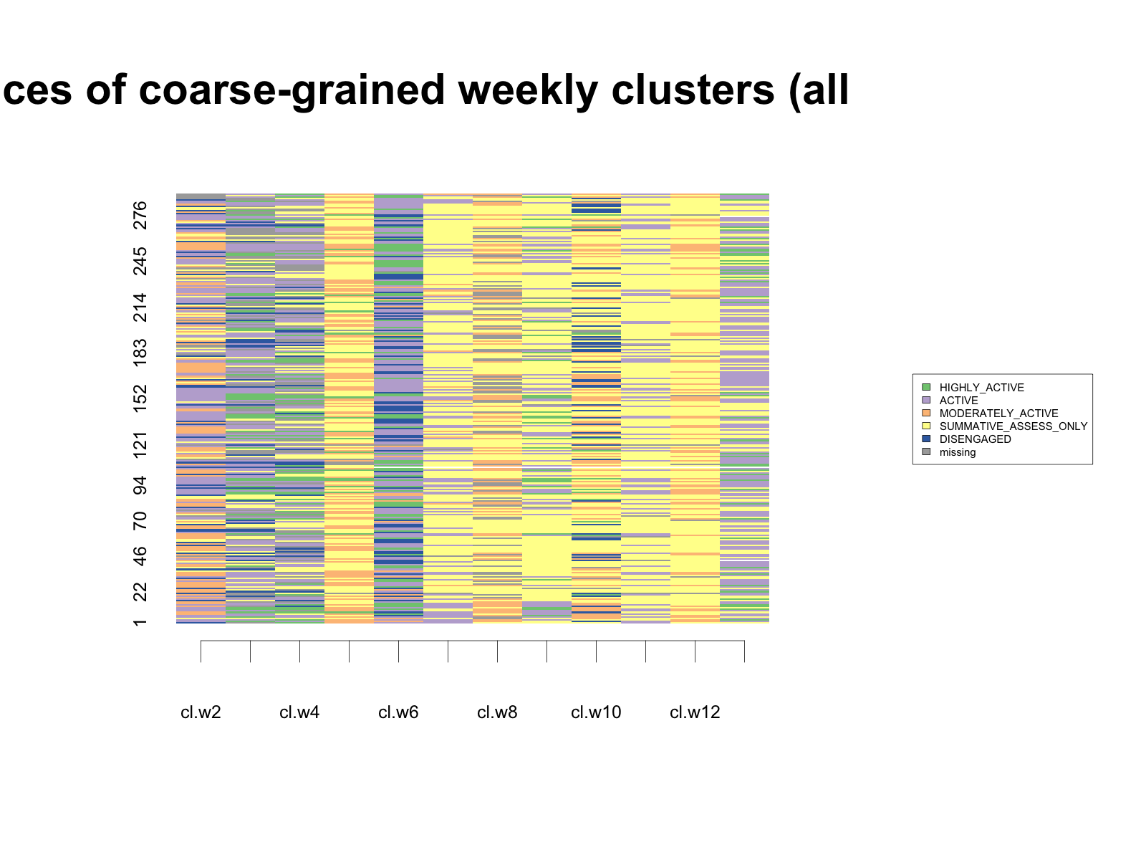

The next figure gives cluster distribution through the course weeks (the same legend applies).

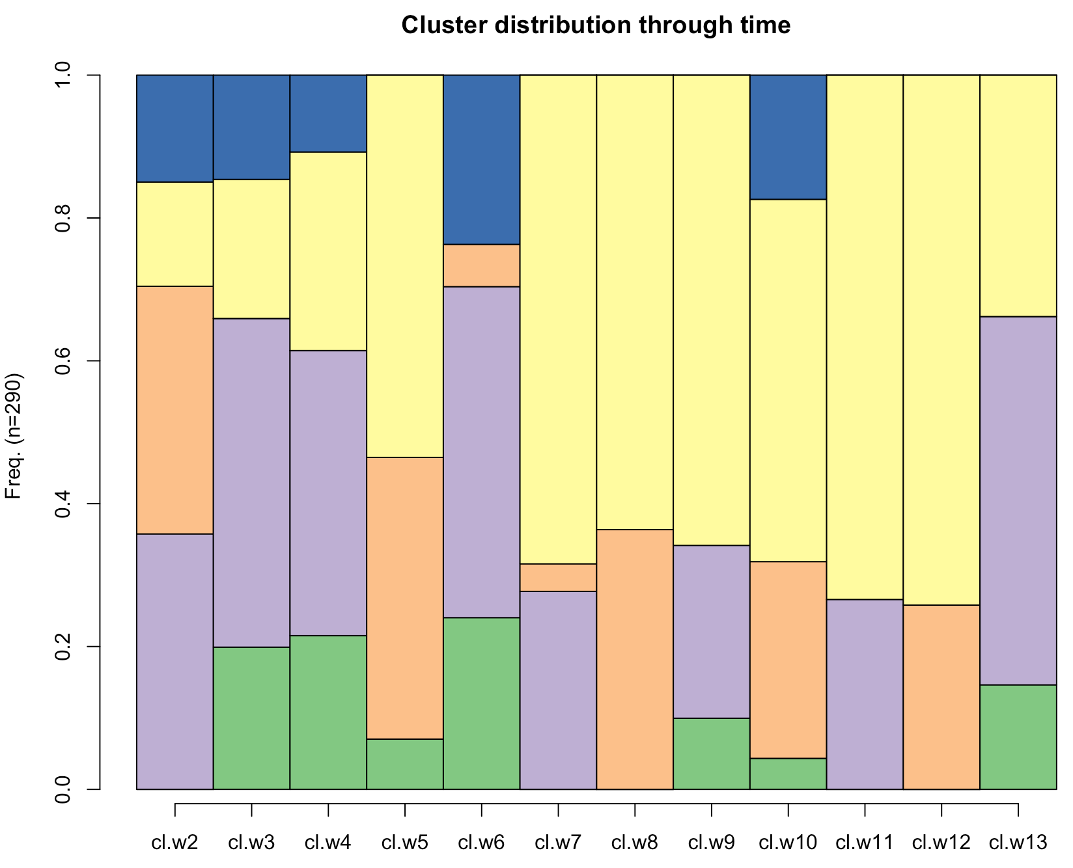

These sequences were then clustered using Ward’s agglomerative clustering algorithm. The solution with 4 clusters seemed to be the best.

Distribution of students across the 4 sequence clusters:

1 2 3 4

66 81 91 52

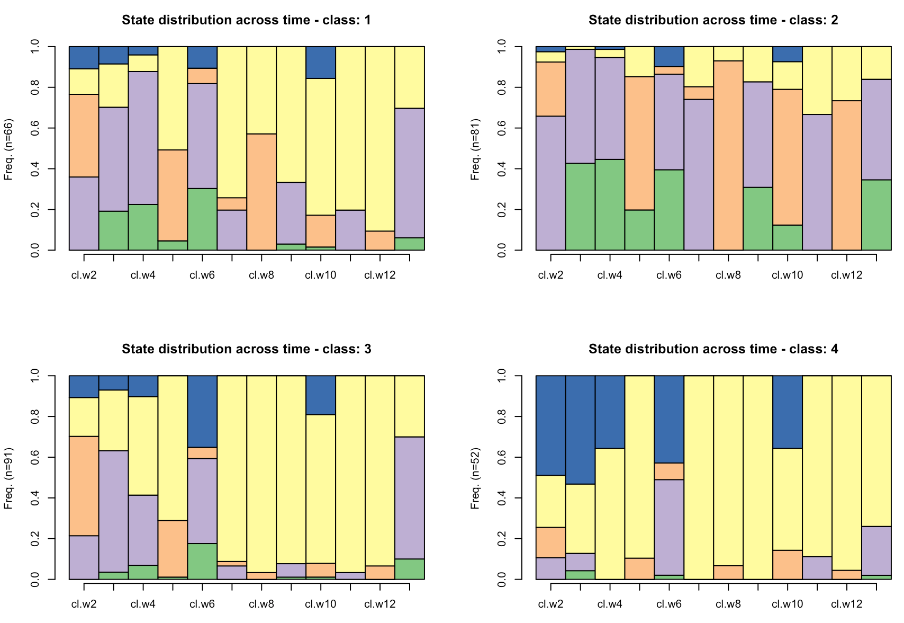

Legend:

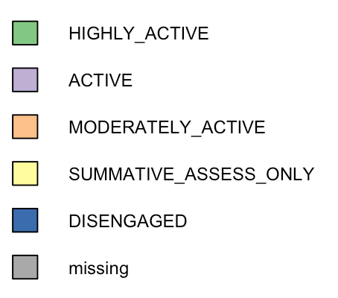

**Comparison of sequence clusters based on the students’ final exam score**

Since data about students’ final exam score are not normally distributed, non-parametric tests were performed: Kruskal-Wallis test followed by Mann-Whitney U test for pair-wise comparison.

Descriptive statistics

===== === ====== === ====

class N median Q1 Q3

===== === ====== === ====

1 66 19.5 15 28.0

2 81 22.0 16 32.0

3 91 15.0 11 20.5

4 52 13.5 10 17.0

===== === ====== === ====

Pairwise comparisons with the FDR correction

=== === === ======= ======== =========== ===========

\ c1 c2 Z p effect.size significant

=== === === ======= ======== =========== ===========

3 1 4 4.9901 0.000000 0.2930 YES

5 2 4 5.5526 0.000000 0.3261 YES

4 2 3 4.4236 0.000007 0.2598 YES

2 1 3 3.5584 0.000326 0.2090 YES

6 3 4 2.0468 0.040501 0.1202 YES

1 1 2 -1.2554 0.210382 0.0737 NO

=== === === ======= ======== =========== ===========

To conclude, significant difference with respect to the final exam score are detected between all pairs of classes, except for the pair 1 – 2.

**Comparison of sequence clusters based on the students’ scores on the MSLQ and SPQ questionnaires**

No statistically significant difference between clusters was found for any of the variables derived from students’ responses to these questionnaires.